###Instructions###

*This is a guide document to help you write the project proposal.*

*You have to remove this "Instructions" section and replace any text between brackets `[` and `]`.*

*NOTE: For readability, individual items in a list are not surrounded by brackets (with the exception of the section titled "Deliverables and Milestones"). Assume these need also be replaced

Also, any other text is written as an example.*

*Post questions in the* ***public discussion forum*** *for the current project.*

*Note: As long as your proposal contains the key parts and descriptions you may format this document as you see fit. However, I highly recommend certain sections such as* "Objectives and Deliverables" *be described via a bulleted list.*

---

###Project 1 Proposal###

####[Project Name]####

**CS40 Cafe**

__Team Composition:__<br>

Mehdi Fourzabadi

Henry Fan

Karthik Krishnamurthy

Daniel Golub

Edin Zade

[Date]

**04/21/2019**

---

####Table of Contents####

[*This page enables the reader to quickly find relevant parts of the document. Including titles and page numbers of each section.

Note: The page numbers are for example only. Change these as you see fit.*]

* 1 Project Overview

* 1.1 Abstract…………………………………….………………………Pg 3

* 1.2 Target Customer……………….…………………………………Pg 4

* 1.3 Search Words……………….……………………………………Pg 4

* 1.4 Scope and Objectives….…………………………………………Pg 4, 5

* 2 Team and Constraints

* 2.1 Team Profile…….……………………………………………….…Pg 6

* 2.2 Challenges……….……………………………………………….Pg 7

* 2.3 Assumptions and Constraints………………………………....Pg 7

* 3 Deliverables and Milestones

* 3.1 Project Deliverables……………………………………………..Pg 8

* 3.2 Schedule and Budget Summary…..…………………………..Pg 9

---

## 1.0 Project Overview

### 1.1 Abstract

**[How would you briefly describe the purpose of your project?]**

*1 - to entertain the audience (players)*

*2 - to improve the decision making and time management skills for users*

*3 - increase awareness (in a pre-training setting) for new employees (like a flight training simulator for pilots)*

*4 - test (recruiting setting) users capability to multitask and track multiple events at the same time.*

[Often readers lack sufficient time to read the entire project proposal. Therefore, a short synopsis is necessary to provide motivation and a high level introduction of the project. ]

* [Give a brief introduction as to ***problem statement***, the ***scope*** and a high level description of the system to be ***delivered***.]

* [Include ***background*** for the project. Motivate the project by describing:

* What is the value of the system over the status quo?

* How will the final product be used by the target customer?]

We have all experienced going to a restaurant and receiving excellent service or disappointing service. Our project would like to uncover some of the constraints of the restaurant associates supply (also know as their motivation and energy) to serve all customers to the best of their ability. Just because an individual experience at a restaurant in terms of wait time, is not meeting your expectations, does not mean that this restaurant provides poor service. This is due to the fact that it is difficult to empathize with your hostess, servers, and bussers when you are not aware of their experience level. Factors include how many people they are having to serve, and how long they have been working already during that shift. This project will educate the general public to obtain better dining out experiences by not over expecting the quality of service, and to not be the unreasonably demanding customer. Rather focus on enjoying their outing more.

From the perspective of prospective employees of restaurants this game provides motivation for multitasking and prioritizing based on differentiated customer needs.

1. This can be supplementary training for new employees. And the skills needed in real life environment can be built in a fun gaming way. And this offers a low risk environment for skill building (for example we are willing to retry and improve in SuperMario versus being shunned in a classroom or peer training sessions).

From the perspective of the employers, this may provide a way of testing the multi-tasking and sequencing capabilities of their employee base.

From our perspective

1. This provides a decomposable problem that we can break up among the team
2. The outcome is something we can explain in our resumes or future interviews
3. We will use many programming skills including UI integration, OS resource management (e.g., clock) and class programming

### 1.2. Target Customer [important part]

[Who is the target audience?]

Four audiences for our solution in order of most important audience to least important audience::

1. Game - our target audience are young adults who want slightly more grounded games that help develop real-world skills (prioritization, multi-tasking and consequences of actions). These skills are being developed in a fun gaming environment.
2. Entertainment/ Mind training like Lumosity.
3. Restaurant owner/ management to view and optimize restaurant operations

[List the intended user group(s):

* Who is client (direct customer)?

Client:

A: Video Game Consumers

B: Restaurant Managers

* Who is user (indirect customer)?]

User:

A: Video Game Consumers

B: Restaurant Employees

For example, for a patient management software the client may be the dental office and users may be Office Manager, Patient Coordinator, and Receptionist.

### 1.3. Search Words

[Brief descriptors of your project that you think someone might use to search for your project. The descriptor may be three to five words or short phrases.]

*[Time management skills, Multitasking skills, Attention to details, decision making skills,, Restaurant training, Customer service skills, Entertainment, Speed game. Gaming]*

###1.4. Scope and Objectives [critical section]

[What is the scope and goals of your group project?]

[The scope describes the specific software system that your team will be designing and delivering.]

Goals:

1. To create a basic scheduling and prioritization game to help our target users (gamers, restaurant employees) build multi-tasking skills in realistic restaurant scenarios
2. To allow for extensibility
   1. Adding more items for example more tables, more menu items , larger number of customers
   2. Extending scope to also include other restaurant processes such as food preparation, stocking etc.
   3. Go beyond standard restaurant to other hospitality categories that require the same skills
3. To provide an interactive user interface for the game

* The ideal project will be a software system that will challenge a team of 4 or 5 students to use a broad range of software engineering skills. This includes skills, such as, requirements: analysis, software design and architecture, implementation, testing, to project planning, scheduling, tracking and documentation.

MVC (model viewer controller) model

Model:

1. Customers [Hurried Customer, Standard Customer, Relaxed Customer]
2. Needs [Menu, Water, Food]
3. There will be a clock within each customer.
4. There is a table with 8 seats for customers.
5. There is a customer queue, if there isn’t a seat for a customer, they will be in the queue.
6. A game clock will keep track of the total game time, and generate a new customer.
7. A scoreboard after the game is over will show all the high scores

Controller:

* When a person enters the restaurant, their clock is set to 0
* The rules for each customer are as follows:
  + Hurried customers have 10 seconds for their menu, 10 seconds for their water, and 20 seconds for food.
  + Standard customers have 15 seconds for menu, 15 seconds for their water, and 30 seconds for food.
  + Relaxed customers have 20 seconds for their menu, 20 seconds for their water, and 40 seconds for their food.
* The rules for the game are as follows:
  + If you meet a customer’s demand for menu you get 1 point, if you meet their demand for water you get 2 points, if you meet their demand for food 3 points
  + If you fail to meet a customers demand, you get 0 points and the customer leaves.
  + If a customer has to wait in a queue for LONGER than 30 seconds, they leave the queue.
  + A customer is generated every 10 seconds.
  + A round in the game lasts for 5 minutes.

Viewer:

* 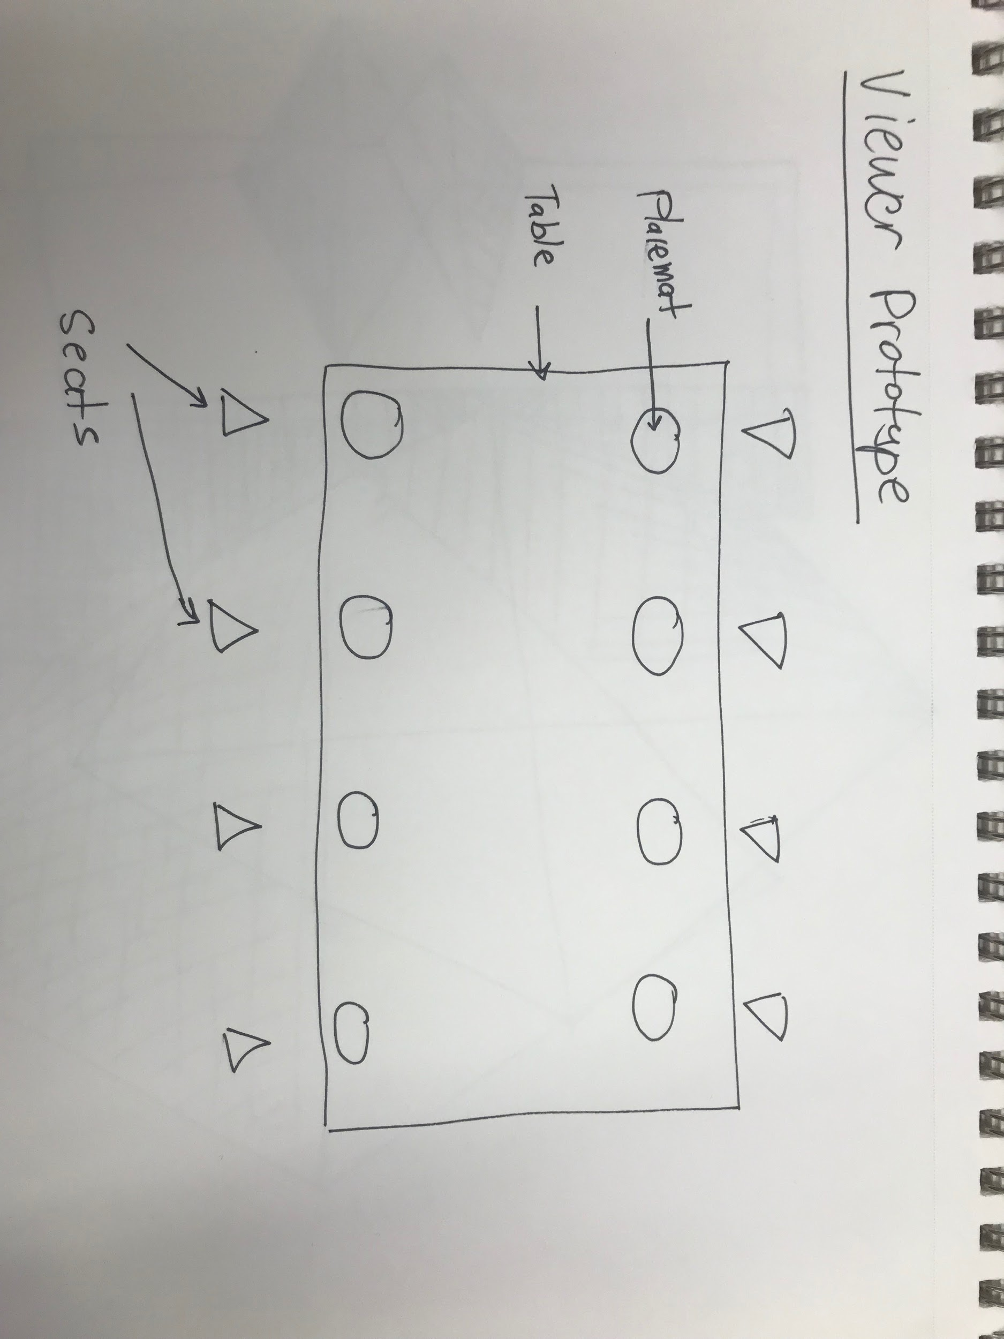

[Reminder:

* Each student will each work approximately 10 hours per week for 4 weeks!!! As part of the team experience, you will be analyzing what the client would be asking from the developers, list the services and features to be provided by the proposed system, estimate the efforts for each service or feature, identify the components that have priority and negotiate project services based on time (and budget constraints).

Note: Rarely does a proposal come in over the top. Instead, more often a proposal is not sufficient in scope and hence not accepted (until modified).*

* For every component, state whether you will be working on the implementation that will support it, or whether you will use existing work. <br>

Note: The implementation involves source code.*]

---

## 2.0 Team and Constraints

###2.1. Team profile

Mehdi Fourzabadi

* I am able to apply personal work experiences and challenges to this project
* I am eager to apply all my previous CS knowledge into this project
* Weakness:
  + Limited project-based experience.

Henry Fan

* Weaknesses: limited java proficiency
* Strengths: scheduling, seeing the potential of the project, working with others

Karthik Krishnamurthy

- some Java experience 1A, 1B

- weakness: not all Java skills are well formed so will have

Daniel Golub

* Strengths are creativity, quick learning and problem solving
* Qualifications are basic knowledge of data structures, java, c++ and python
* Has worked in the hospitality industry

[For each member of the team ***describe qualifications and strengths

Note: Every team member is expected to be involved in all project activities. This section only describes individual strengths, and NOT the team member’s sole responsibility.*]

### 2.1. Challenges

[What are the challenges you foresee in successfully completing your project?]

[Provide a ***description of challenges*** that your group might face. These are often technical and non-technical aspects that may not be apparent to the reader.]

1. Merging the different components of each individual’s contribution
2. Scope creep: keeping our scope tight & achievable.
3. Modular: deliver a complete project
4. Getting team on the same page
5. Technical barriers of participation

For example, if you were creating a software system for a dental office to manage patients, a challenge may be learning the domain, which involves following HIPPA regulations in disclosure of protected health information.

There is a domain advantage as multiple members of our team have worked (or currently work) in the food / hospitality industry

### 2.2. Assumptions and Constraints

[Under what assumptions and constraints will the team adhere to?]

We are assuming there are only **3** types of customers, and each customer has **3** distinctive demand’s, also known as “needs”.

1. A patient customer will demand the least amount of attention (least amount of need, which means least *amount* of help)
2. A typical customer will demand the average amount of attention (standard amount of need)
3. A difficult customer will demand the most amount of attention (most amount of need, which means most *amount* of help)

Our constraints are defined by the amount of service (amount of attention and help) the restaurant's associates may supply to our customers. Once our customers occupy the attention limit (use up the supply of help), we may constrain our demand by letting the customers wait.

[**List any specific assumptions on which the project is based on and imposed constraints** that your team will be working under. Non-technical constraints could be: such as schedule and budget. Technical constraints may be design or implementation metholodogies, tools, operating system(s), hardware or software constraints.

* Non-Technical Constraints:

* Project time - and to address we are keeping simple UI and a tight scope: 8 seats, 30 customers over 5 mins, 3 items [4 states including empty] and 3 types of customers

* Physically meeting and coordinating as a team. We are addressing three ways

1. Team meeting times each T and Th after class
2. Google docs (and possibly webex) for collaborating
3. We are collaborating actively and respectful

* add here...

* Technical Constraints:

* add here...]

---

##3.0 Deliverables and Milestones

### 3.1. Project Deliverables

[What are the specific delivarables by your team?]

[***Provide a list of deliverables***<sup>4</sup> of any project artifacts.]

Deliverables include:

* Software System Project Proposal.

* [design document]

* [user manual and installation instructions]

* [presentations]

* [any other documents]

* [UML overview of different components in your system (see NOTE below)]

* [implementation code]

* [unit tests and test suites (see NOTE below)]

* [This list may include product deployment activities that are necessary for the successful use of the system your team develops.]

Note: This list may be modified over the weeks until the final submission.*

NOTE: Required by final submission of project.

### 3.2. Schedule and Budget Summary [critical section]

[What are the projected milestones and specific delivarables?]

[Fill in your teams projected milestones. You will be modifying this over the next few weeks.]

####Milestones

| Item | Date |

| :--------------------------|:-----------------|

| Project Proposal | April 22, 2019 |

| Proposal Presentation | April 23, 2019 |

| [feature 1] | [expected date] |

| [feature 2] | [expected date] |

| ... | [expected date] |

| Sprint 1 | April 25, 2019 |

| ... | [expected date] |

| Demonstration and Delivery | May 23, 2019 |